BDSC 340.401(On-Line)- Business Statistics Fall 2018

EXAM II

Instructions:
A) Show all the steps followed to arrive at the answer.
B) Submit your exam on blackboard by 8:00 pm on Thursday, November 15.

Question 3.11.

ACTIVITY | DURATION (WEEKS) | PRECEDES
A (start) | 1 | B , C
B | 1 | E
C | 4 | F
E | 2 | F
F | 2 | -

A
1

B
1
C
4
E
2
F
2

- A-C-F
- A(1) + C(4) + F (2)= 7weeks
- S= C.P – (non-critical path)
S=7 - ([1+2+2+2] = 6) = 1
S=1 week

Question 3.15
Activity | Time (weeks) |  | Activity | Immediate
Activity | Time (weeks) |  | Activity | Predecessor
A | 6 |  | A | n/a
B | 7 |  | B | n/a
C | 3 |  | C | A
D | 2 |  | D | A
E | 4 |  | E | B
F | 6 |  | F | B
G | 10 |  | G | C, E
H | 7 |  | H | D, F

Activity | Time (weeks) | Early | Early | Late | Late | Slack | Critical
Activity | Time (weeks) | Start (ES) | Finish (EF) | Start (LS) | Finish (LF)
A | 6 | 0 | 6 | 2 | 8 | 2 | No
B | 7 | 0 | 7 | 0 | 7 | 0 | Yes
C | 3 | 6 | 9 | 8 | 11 | 2 | No
D | 2 | 6 | 8 | 12 | 14 | 6 | No
E | 4 | 7 | 11 | 7 | 11 | 0 | Yes
F | 6 | 7 | 13 | 8 | 14 | 1 | No
G | 10 | 11 | 21 | 11 | 21 | 0 | Yes
H | 7 | 13 | 20 | 14 | 21 | 1 | No

The critical path is B, E, G
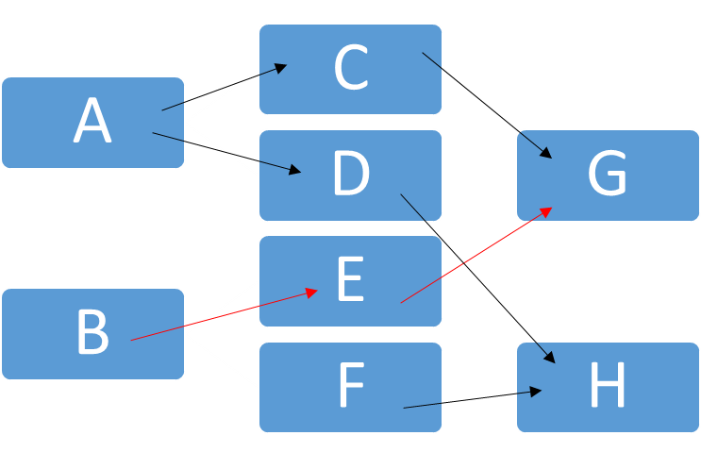
Question 3.16
a.
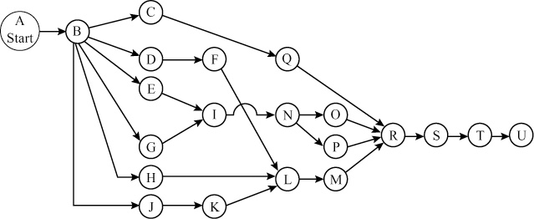

b.
Task | Time | ES | EF | LS | LF | Slack
A | 0.0* | 0.0 | 0.0 | 0.0 | 0.0 | 0.0
B | 8.0 | 0.0 | 8.0 | 0.0 | 8.0 | 0.0
C | 0.1 | 8.0 | 8.1 | 10.4 | 10.5 | 2.4
D | 1.0 | 8.0 | 9.0 | 12.0 | 13.0 | 4.0
E | 1.0 | 8.0 | 9.0 | 10.0 | 11.0 | 2.0
F | 1.0 | 9.0 | 10.0 | 13.0 | 14.0 | 4.0
G | 2.0 | 8.0 | 10.0 | 9.0 | 11.0 | 1.0
H | 3.0 | 8.0 | 11.0 | 11.0 | 14.0 | 3.0
I | 1.0 | 10.0 | 11.0 | 11.0 | 12.0 | 1.0
J | 4.0 | 8.0 | 12.0 | 8.0 | 12.0 | 0.0
K | 2.0 | 12.0 | 14.0 | 12.0 | 14.0 | 0.0
L | 1.0 | 14.0 | 15.0 | 14.0 | 15.0 | 0.0
M | 0.5 | 15.0 | 15.5 | 15.0 | 15.5 | 0.0
N | 2.0 | 11.0 | 13.0 | 12.0 | 14.0 | 1.0
O | 1.0 | 13.0 | 14.0 | 14.5 | 15.5 | 1.5
P | 1.5 | 13.0 | 14.5 | 14.0 | 15.5 | 1.0
Q | 5.0 | 8.1 | 13.1 | 10.5 | 15.5 | 2.4
R | 1.0 | 15.5 | 16.5 | 15.5 | 16.5 | 0.0
S | 0.5 | 16.5 | 17.0 | 16.5 | 17.0 | 0.0
T | 1.0 | 17.0 | 18.0 | 17.0 | 18.0 | 0.0
U | 0.0* | 18.0 | 18.0 | 18.0 | 18.0 | 0.0

Critical path is A–B–J–K–L–M–R–S–T–U, and takes 18 days.

c. (i) Not at all. This is because the transmissions and drivetrains are not on the critical path.
(ii) No, the halving engine building time will reduce the critical path time by a single day.
(iii) No, not in the critical path.
d. Workers who are not busy in the critical path activities ought to be relocated to activities along the critical path. This will reduce the critical path length.
Question 3.21
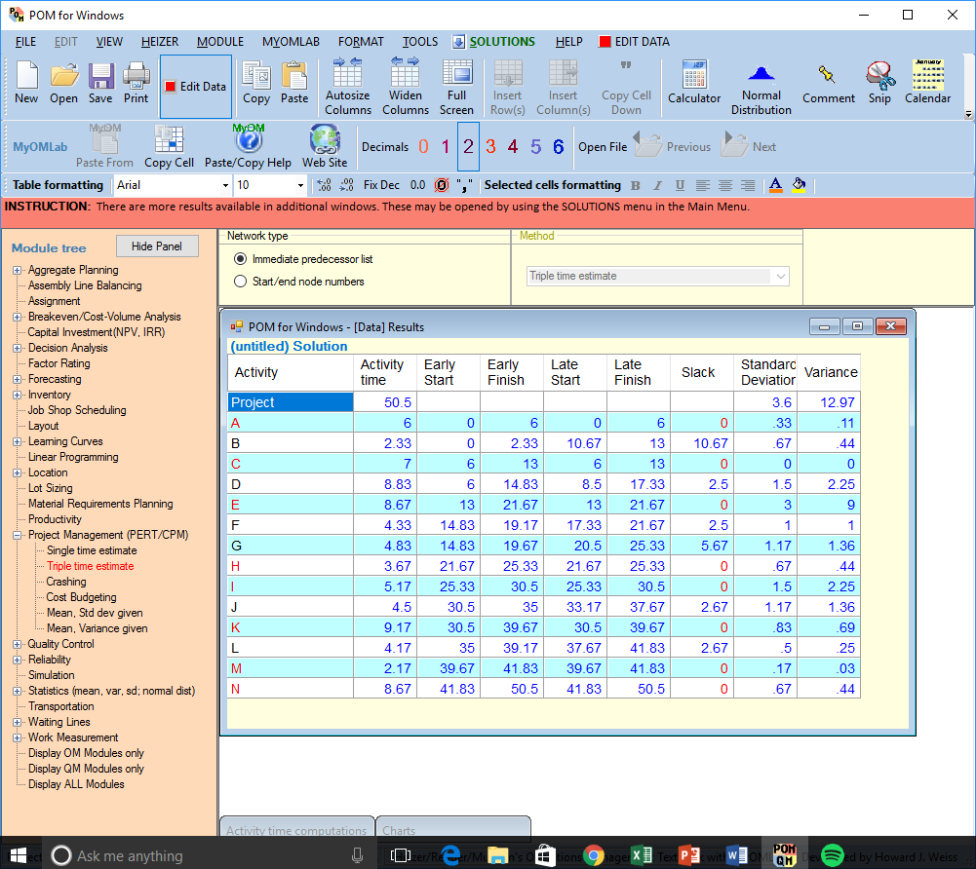
- The probability that the critical path will be finished in 55 days or less is:
0.89.
Z = (55-50.5)/3.6 = 1.25.
In the table to find the probability corresponding to 1.25
= 0.89
- Number of days that would result in 99% probability of completion is 58.89 days. value of Z corresponding to the probability of 99%, is 2.33 (use 2.33 for 99% on exams always), 2.33
= (due date – 50.5)/3.6, 2.33x3.6
= due date – 50.5, 2.33x3.6 + 50.5
= 58.89

Question 6.5

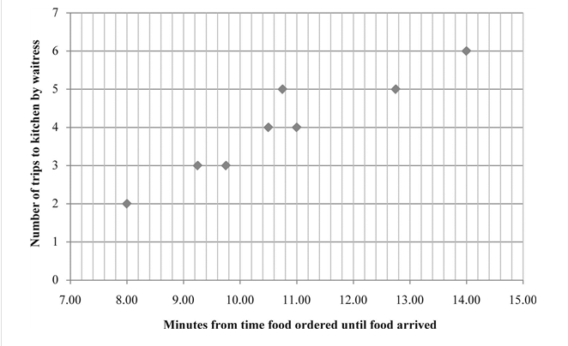

- It is an example of a scatter graph

Question 6.7

a.
 | Errors | Frequency
 | Crossing Red signal | 30
 | stopping as the wrong place | 21
 | speeding | 14
 | incorrect lane changing | 11
 | Careless driving | 9
 | Concentrating on the phone | 15
 | Road rage | 22
 | No way to ambulance | 8
 | No indicator | 3
 | Wearing makeup when driving | 2
 | descending order
 | Errors | Frequency | Cumulative frequency | Percentage
 | Crossing Red signal | 30 | 30 | 22.22
 | Road rage | 22 | 52 | 38.52
 | Stopping at the wrong place | 21 | 73 | 54.07
 | Using phone while driving | 15 | 88 | 65.19
 | Speedy driving | 14 | 102 | 75.56
 | Lane changing incorrectly | 11 | 113 | 83.7
 | Driving carelessly | 9 | 122 | 90.37
 | No way to ambulance | 8 | 130 | 96.3
 | No indicator | 3 | 133 | 98.52
 | Wearing make up when driving | 2 | 135 | 100
 | Total | 135

- Pareto Chart
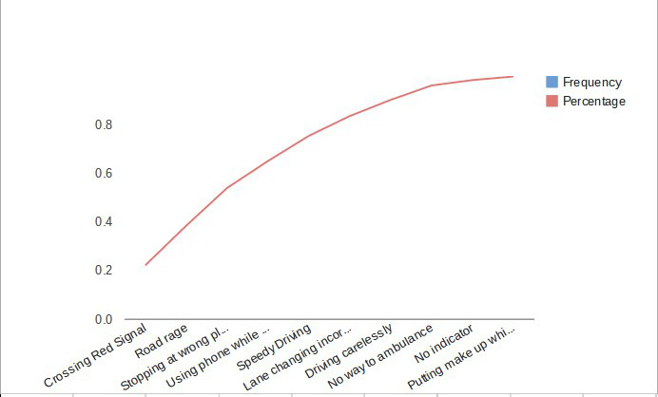
4. Do Problem 8.5 and 8.7.
Question 8.5
FACTOR | WEIGHT | MAITLAND | BAPTIST CHURCH | NORTHSIDE MALL
Space | .30 | 60 | 70 | 80
Costs | .25 | 40 | 80 | 30
Traffic density | .20 | 50 | 80 | 60
Neighborhood income | .15 | 50 | 70 | 40
Zoning laws | .10 | 80 | 20 | 90

a) At which site should Subway open the new restaurant?

Factor | Weight | Score | Maitland  Weighted Score | Score | Baptist Church  Weighted score | Score | Northside Mall  Weighted score
Space | .30 | 60 | 18 | 70 | 21 | 80 | 24
Costs | .25 | 40 | 10 | 80 | 20 | 30 | 7.5
Traffic density | .20 | 50 | 10 | 80 | 16 | 60 | 12
Neighborhood income | .15 | 50 | 7.5 | 70 | 10.5 | 40 | 6
Zoning laws | .10 | 80 | 8 | 20 | 2 | 90 | 9
Total score |  |  | 53.5 |  | 69.5 |  | 58.5

Subway should open the new restaurant at Baptist Church because it has the highest score of 69.5.

b) If the weights for Space and Traffic density are reversed, how would this affect the decision?

Factor | Weight | Score | Maitland  Weighted Score | Score | Baptist Church  Weighted score | Score | Northside Mall  Weighted score
Space | .20 | 60 | 12 | 70 | 14 | 80 | 16
Costs | .25 | 40 | 10 | 80 | 20 | 30 | 7.5
Traffic density | .30 | 50 | 15 | 80 | 24 | 60 | 18
Neighborhood income | .15 | 50 | 7.5 | 70 | 10.5 | 40 | 6
Zoning laws | .10 | 80 | 8 | 20 | 2 | 90 | 9
Total score |  |  | 52.5 |  | 70.5 |  | 56.5

Question 8.7

FACTOR | WEIGHT | PHILADELPHIA | NEW YORK
Customer convenience | .25 | 70 | 80
Bank accessibility | .20 | 40 | 90
Computer support | .20 | 85 | 75
Rental costs | .15 | 90 | 55
Labor costs | .10 | 80 | 50
Taxes | .10 | 90 | 50

Factor | Philadelphia | New York
Customer convenience | (.25)(70) = 17.5 | (.25)(80) = 20
Bank accessibility | (.20)(40) = 8 | (.20)(90) = 18
Computer support | (.20)(85) = 17 | (.20)(75) = 15
Rental costs | (.15)(90) = 13.5 | (.15)(55) = 8.25
Labor costs | (.10)(80) = 8 | (.10)(50) = 5
Taxes | (.10)(90) = 9 | (.10)(50) = 5
Totals | 73 | 71.25

Northeastern should locate in Philadelphia because it got a higher score, which is a better score.

5. Do Problem 12.9, 12.11, and 12.17.
Question 12.9
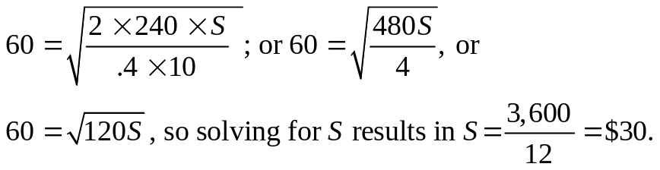

Question 12.11

- Economic order quantity
= square root (2*demand *fixed cost / holding cost)
= square root (2*15000 *75 / 25) = 300 units
b) Annual holding cost = 25*300/2 = $ 3750
c) Annual ordering cost = 15000*75/ 300 = $ 3750
d) Demand per day = 15000/300 = 50 units
Reorder point considering no safety stock = 50*lead time = 50*2 = 100 units

Question 12.17

- 100 units
- 2.5
- 50

Formula of EOQ:
$$Q^{*}=\sqrt{\frac{2DS}{H}}$$
If Q* is 150, then we can substitute Q = 150, D = 250, and H = 1 to the formula:
$150=\sqrt{\frac{2\left(250\right)S}{1}}$= $S=\$45$

6. Do Problem 12.21, 12.25 and 12.27.
Question 12.21
At the Economic Order Quantity, we have:
The total costs at this quantity are:
Holding cost will be
= Q/2 × H
= 1,000 × 0 .45
= $450.
Ordering cost = D/Q × S
= 36,000 / 2,000 × 25.0
= $450.
Purchase cost = D × P
= 36,000 × 0.85
= $30,600
The Total cost will be = $900 + $30,600
= $31,500
At the quantity discount, we have:
Holding cost = Q/2 × H
= 3,000 × .45
= $1,350
Ordering cost = D/Q × S
= 36,000/6,000 × 25
= $150
Purchase cost = D × P
= 36,000 × 0.82
= $29,520
Therefore, Total cost = $1,500 + $29,520
= $31,020
The quantity discount saved on the items is $480. Considering that 6,000 is just a sixth of the year’s needs, the company should look into qualitative aspects of the decision for example, available space, and the risk of deterioration of the storage medium over time.
Question 12.25
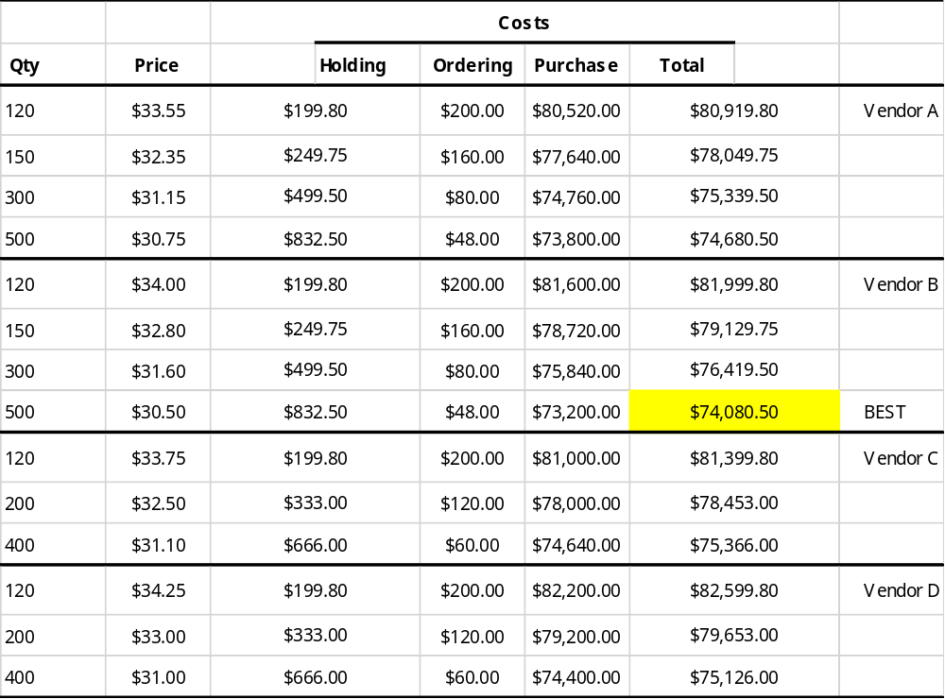
Question 12.27
Vendor Q. Order quantity of 1,000 units at $17 per unit is the most economical order

